Chapter 5 Practice Test: Ratios, Proportions, Rates, and Slope
NAME: ______________________________
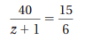
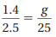
Solve each proportion using cross products. Show all work. Round decimals to nearest hundredth.
1. 2. 3.

Write a proportion with units for each situation. Solve using Cross Products.
4. If there are 300 calories in a 6 oz. bagel, how many calories are in a 4 oz. bagel?

5. Jordan can enter 25 letters on a text message in 10 seconds. How long will it take him to enter a message that is 20 letters long?

Proportionality:
- Show if table is in proportion. If it is, find the constant of proportionality. Show your work!
X (min) | 7.5 | 10 | 17.5 | 20
Y (apples eaten) | 4.5 | 6 | 10.5 | 12

Proportional? Why? If so, what is k with units?

- Show if table is in proportion. If it is, find the constant of proportionality. Show your work!
X (sec) | 1.5 | 2 | 3.5 | 5
Y (breaths taken) | 10.5 | 14 | 24.5 | 35

Proportional? Why? If so, what is k with units?

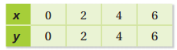
Use a graph to tell whether x and y are in a proportional relationship.
3) 4)
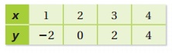

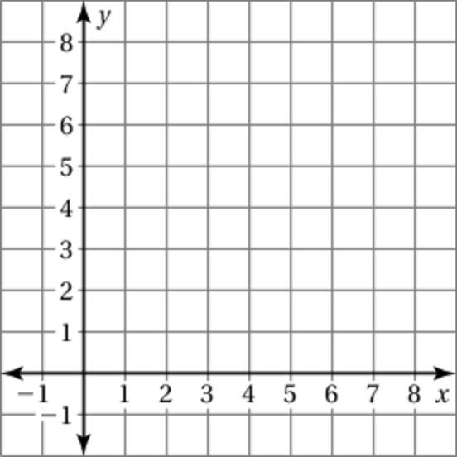
Slope: __________ Slope: _______
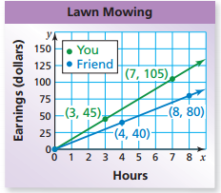
5. The graph shows how much you and a friend earn mowing lawns.
a) Which line is steeper? What does this mean in the context?

b) Slope of You (UNITS): _________
Slope of Friend (UNITS): _________
c) How much more money do you earn per hour than your friend?

d) Explain the meaning of the point (4,40) in the context of this situation IN A COMPLETE SENTENCE.

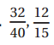
6. Proportional or not? Show evidence!

7. Find the Unit Rates:
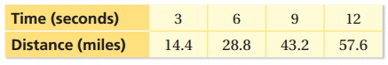
a) b) Find Miles per Second

8) What are the four types of slope? _____________________________________________________________
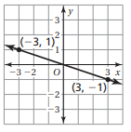
9) Find the slope.
a) b) Show formula work. (-3, -8) and (-1, -2)

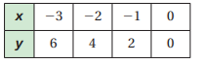
10) The points in the table lie on a line. Find the slope.

