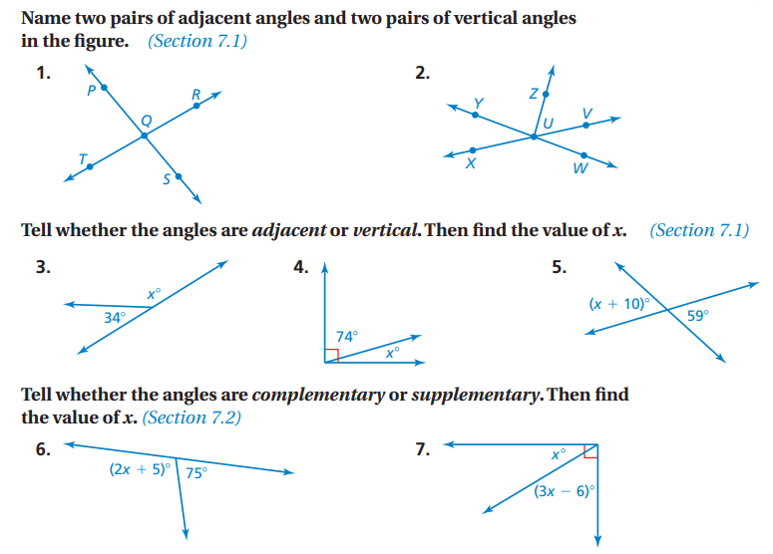

8. Draw a pair of adjacent supplementary angles, one of which is 63 ͦ. Use a protractor.

9. Draw a pair of vertical angles measuring 85 ͦ. Use a protractor.

10. a) Draw a triangle with angle measures of 35 ͦ and 80 ͦ. Measure the third angle with your protractor.

b) Use your protractor to draw an obtuse scalene triangle. Label all three angles.

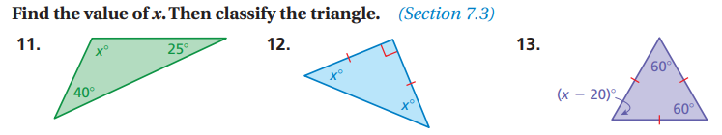

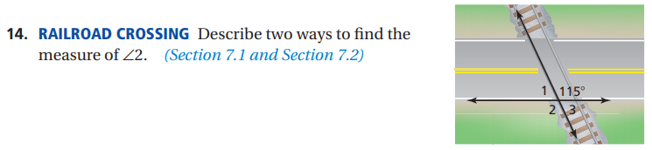

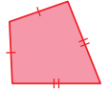
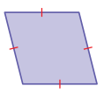
15. Classify the quadrilaterals:

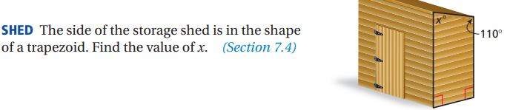
16.

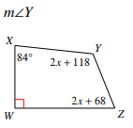
17. Show equation work! Find

