Quadrilaterals: Name and Find Missing Angles
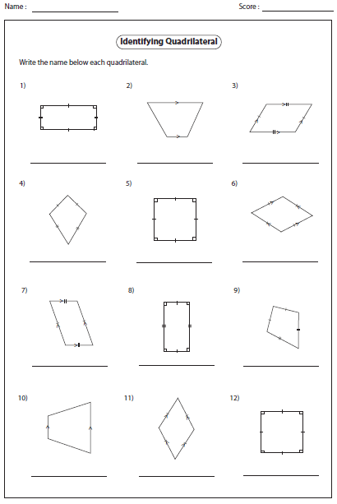
Classify the quadrilaterals below:

For each figure below:
Write an algebraic equation and solve for x. ****The four interior angles in a quadrilateral add to: _____⁰

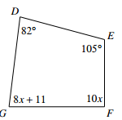
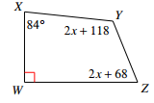
7. 8. What is the measure of $∠$G in #7?

