Practice Test: Chapter 6 Percents
NAME: _________________________

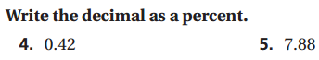

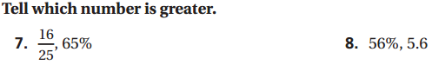

Solve using the percent proportion or equation. Show work!
9. 30% of 117 is what? 10. 11 is what percent of 97? 11. 120% of 118 is what?

12) There are 845 students at Webber. Of these, 65% bring their own lunch. How many bring their own lunch?

13) Original: $75 14) Original: 520 hours
New: $106 New: 450 hours
Find Percent Change. Increase or decrease? Find Percent Change. Increase or decrease?

15) Last year, 25 students preferred taking tests on paper. Now, only 14 students prefer taking tests on paper! The rest prefer computer-based tests. What is the percent decrease for this situation?

16) Use the percent of change to find the new amount. Show work!
$75 decreased by 30%

17) The bill for dinner was $76.00. It is courteous to leave a tip of 15%. How much money should Chuck leave for a tip of 15%? Show your work.

18) A man wants to buy a new winter suit and finds one he really likes, but it’s too expensive at $139.00. So he decides to wait. After Christmas, the price is marked down by 35%. What is the new price?

19) You put $800 in an account that earns a rate of 4% simple interest. Find the total amount in your account after 3 years.

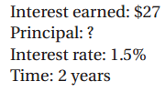
20)

21) Yesterday, Maria only paid $550 for a brand new laptop because it was on sale for 45% off. What was the original price of the laptop?

