A.
20%
B.
158.8% Increase
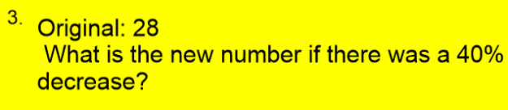 |  | C.  $39.15
4. |  | D.  83h
5. |  | E.  54
6. |  | F.  41.5% Increase
7. |  | G.  16.8
8. At your summer job, you make $68 per day. After going to college for computer science, you will make $176 per day. What is the percent change? |  | H.  54.55% Decrease

