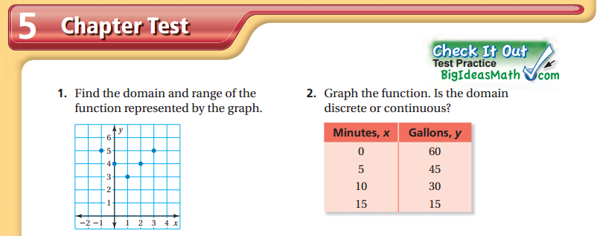

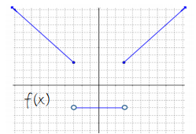
Use the functions to answer the questions below:
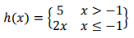
3) f(0) = 4) h(-5) =

5) h(-1) = 6) h(3) = 7) f(x) = 5

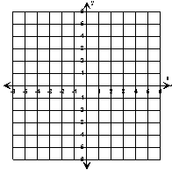

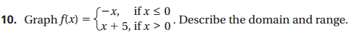

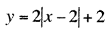
13. Graph the function:

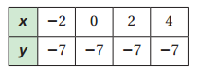
14. Is this relation a function? If so, write a function rule (equation).

15. The price for adults and price for students to go to a play is modeled by the equation 5x + 3y = 45.
a) Write the equation in function form (solve for y).
b) Is the domain discrete or continuous?
c) Graph the function. Label axes.

