Practice Quiz 5.1-5.4

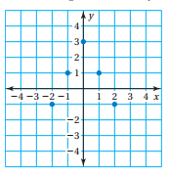
Find the domain and range of the functions. (Section 5.1 & 5.3)
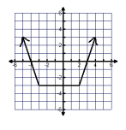
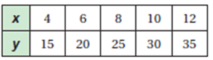
1. 2. 3.

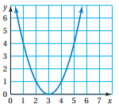
Explain whether the following relations are functions or not using a mapping diagram or the vertical line test. (Section 5.1e)
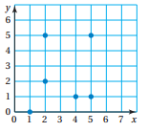
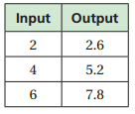
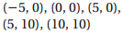
4. 5. 6. 7.

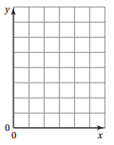
8. Create scales, label axis, and graph the following functions.
Is the domain discrete or continuous? (Section 5.2).
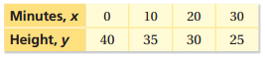

9. Graph the functions with the given domain. Discrete or continuous?

a) y = 3x; Domain: -2 < x < 2 b) y = -3; Domain: -4, -2, 0, 2
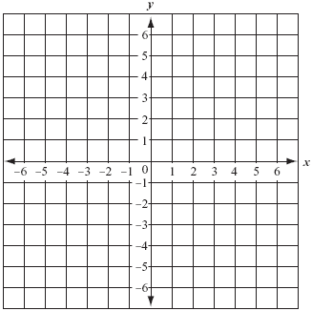

Use the graph or table to write a function that relates y to x. (Section 5.3)
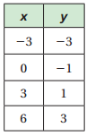
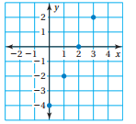
10. 11.

12. The function m = 30 – 3r represents the amount m (in dollars) of money you have after renting r video games. Graph the function using a domain of 0, 1, 2, 3, and 4. Is the domain discrete or continuous? Make sure to include a scale and labels! (Section 5.2)
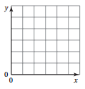

Let f(x) = 3x – 4, g(x) = 2x, and h(x) = x² + 1.
13. Find f(-5) 14. If h(x) = 65, find x. 15. Find g(-200)

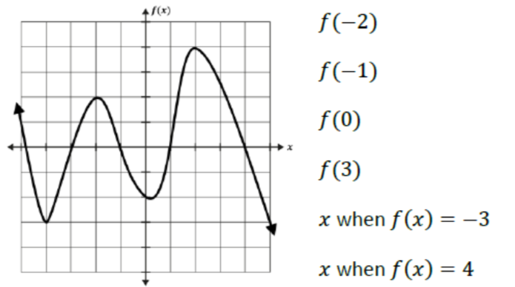
16. Answer the questions using the graph:

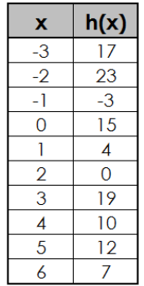
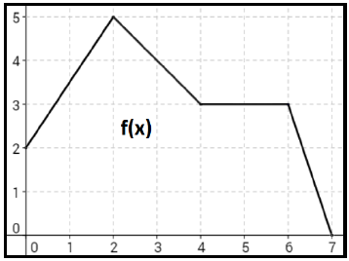
17. Find (f+h)(4)

