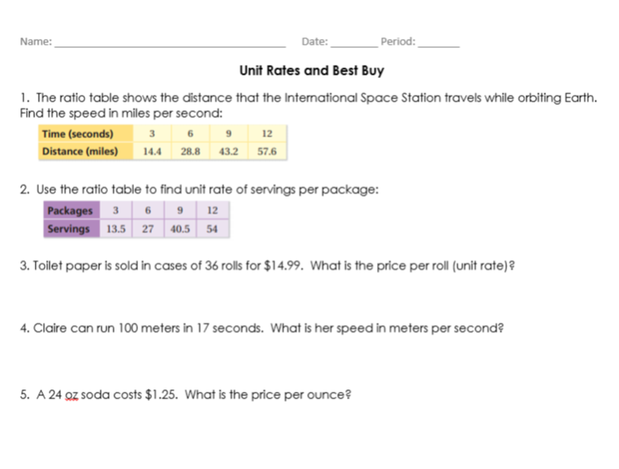

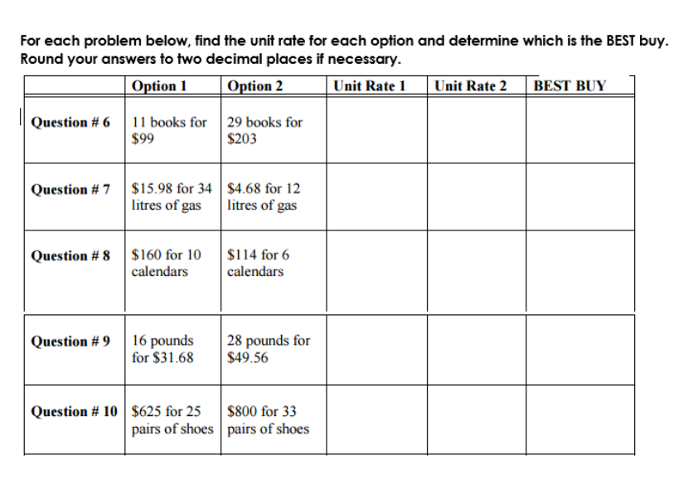

Calculate New Amounts:
11) Ryan made 240 cookies in 5 hours. How many total cookies could he make if given 12 hours?

12) Alena is training for a marathon next summer. Last week she ran 9 miles in 2.5 hours. How far could she run in 6 hours?

Convert to Unit Rate with units:
13) $\frac{2 in.}{\frac{3}{4}sec}$

