Wkst Quiz Review 4.1-4.2 Name _______________________________________

**Set up and solve each system. Make sure to define variables!**

1) Kristin spent $131 on shirts. Fancy shirts cost $28 and plain shirts costs $15. If she bought a total of 7 shirts, how many of each kind did she buy? Define your variables.

x=

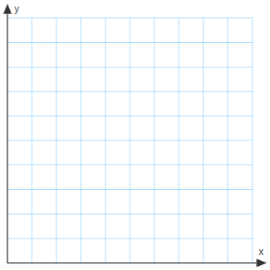y=

2) There are 13 animals in the barn. Some are chickens and some are pigs. There are 40 legs in all. How many of the animals are pigs and how many are chickens? **GRAPH this system**.

x=

y=

3) A class of 195 students went on a field trip. They took 7 total vehicles: some cars and some buses. Find the number of cars and buses they took, if each car holds 5 students and each bus holds 45 students.

x=

y=



4) Suppose you are starting an office-cleaning service. You have spent $100 on equipment and to clean each office you use $5 worth of supplies. You charge $25 per office. How many offices must you clean to break even? **GRAPH this system**.



x=

y=

5) The price of a sweater is $5 less than twice the price of a shirt. If four shirts and three sweaters cost $275, find the price of each shirt and each sweater.

x=

y=

**Solve these systems by GRAPHING:**

6) 3x + 4y = 12 7) y = (1/2)x + 2

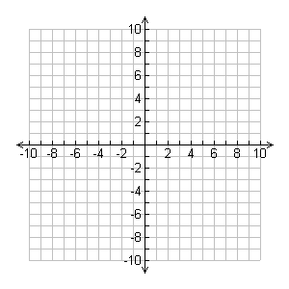 2x + 4y = 8 y = -1 x + 5

Solution: _________Check**:** Solution: _________Check**:**

**Solve these systems using SUBSTITUTION:**

8) y = 4x + 11 9) 3x + 5y = 2 10) y = -5x - 2

-6x + 8y = 36 x + 4y = -4 5x + y = 0



11) 12)