Write the area of each rectangle as the product of length x width (factored form) and also as the sum of the areas of each box (expanded form).
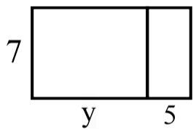
1. Factored:
Expanded:

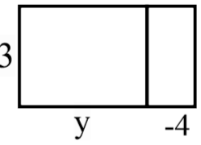
2. Factored:
Expanded:
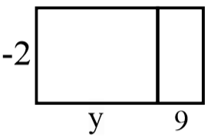
3. Factored:
Expanded:

Use the Distributive Property to re-write each expression as a sum (expanded form). You may want to draw a rectangle to follow the technique above.
4. -2(x + 4) 9. -6(y – 7)

5. x(x + 9) 10. –(5x + 8)

6. -4(a – 4) 11. -5x(3 – 2 + 6x – 2x)

7. a(a – 12) 12. -3(2x + 1) – 3x

8. -11(3x + 1) 13. 5 – 3(-4x – 2) + 10x

