Chapter 2 and 12.5 Practice Test Name ________________________________ Per ____
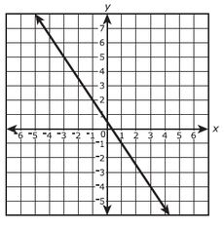
1) Find the slope of the line. m = ________ 2) A line passes through (1, 3) and (6, 4). Write an equation for the line in point-slope form.

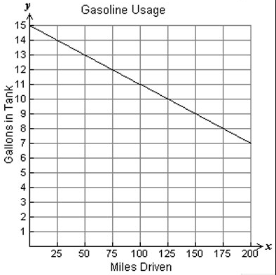
3) a. Write a slope-intercept equation ________________________

b. What does the slope and y-intercept mean in context of the situation? (Two complete sentences.)

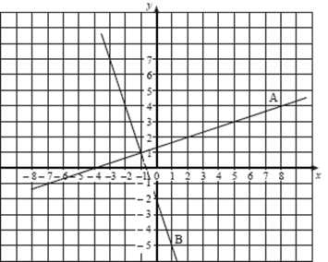
4) Use the graph below to write the equations in the specified form.
a) Line A: Write an equation in point-slope form.

b) Line B: Write an equation in slope-intercept form.

Identify the slope and y-intercept of each equation. Show your work!
5) 6x + 5y = 10 m = _____ b= _____ 6) y – 4 = –3(x + 5) m = _____ b = _____

Find the x- and y- intercepts of each line. Write each intercept as a coordinate point. Show your work!
7) 2x + 5y = 10 8) x = –5 + 3y

Graph each equation from the form given! Do not transform.
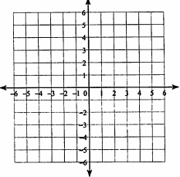
9) $y=\frac{1}{4}x-3$ 10) $y-4=-\frac{3}{5}(x+2)$ 11) $4x-3y=12$

12) Graph the equation. $y=6$ 13) a) Explain the relationship between temperature and beach temps.
Is there a correlation?

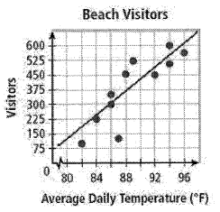
b) Write an equation for the trend line using the points (96, 610) and (84, 250) in slope-intercept form.

14) Four months at a gym costs $220. The rate is $40 per month.
a) Define your variables and write an equation in the appropriate form to model this situation.

b) How much would it cost to be a member at the gym for 3 months? Show work algebraically.

15) Sara started with $4,000 in her savings account. Each month she adds $200.
a) Define your variables and write an equation in the appropriate form to model this situation.

b) If Sara has $5400, in her savings account, how many months has she been adding money? Show work algebraically!

16) The store sells peanuts for $3 per pound and pecans for $5 per pound. You have $24 to spend on nuts.
a) Define your variables and write an equation in the appropriate form to model this situation.

b) Graph your equation and label your axes.
c) What does the x-intercept mean (specifically!) in the context of the situation?

17) What is the equation of a line in slope intercept form that is perpendicular to the line y = -3x + 2 and passes through the point (-6, 2)?

