**Practice Quiz 1.1-1.2**  Name ________________________________ Period _____

**Solve the equations below. Show all steps!**

1) -x + 2 = 12 2)  3) 

4)  5) - 1.2x = 8.4 6)

7) -5(3x + 12) = -15 8) 5(b + 4) – 6b = -24 9) -3π + x = 2π

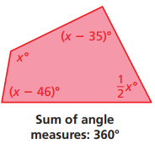

10) Write an equation and solve to find the value of x.

Equation:

Solve:

**For each situation below: A) Define a variables x & y B) Write a linear equation (DON’T SOLVE)**

11) A customer went to a flower shop and bought some greenery for $3.00 and 5 roses. The total bill was $7.50. What was the price of each rose?

12) Daniel’s cell phone plan is $29.95 per month, plus $0.10 per minute for each minute over 300 minutes of call time. Daniel’s cell phone bill is $99.95. For how many minutes was he billed?

13) A concert ticket costs $45 per person. Write an equation that shows how many people went to the concert if the total revenue was $1,710.

14) Evaluate the expressions below if a = -2, b = 3, and c = -1  **(Show substitution first!)**

a) 5 – ab b) c2 – a